**Design And Simulation of a Cylindrical Dielectric Resonator Antenna for Biomedical Applications**

**Mohd Minhal1, Anshuman Tiwari2, Rakesh Kumar Yadav 3**

Department of Electronics and Communication Engineering,

Babu Banarasi Das Northern India Institute of Technology

Lucknow, Uttar Pradesh, India

***Abstract*—*To detect glucose in humans, a dielectric resonator antenna in the shape of a cylinder is introduced. In the suggested antenna sensor, a 50Ω microstrip line connects an Alumina ceramic dielectric resonator. The glucose concentration is measured by placing the person's thumb on the dielectric resonator. The concentration of glucose has an impact on the thumb's blood's dielectric constant. Thus, changes in blood permittivity result from variations in glucose concentration, which in turn causes a change in the input impedance of the suggested sensor. The resonance frequency shifts as a result of this fluctuation. Through simulated results acquired in the CST Microwave Studio, a full-wave electromagnetic simulator, the validity of this concept has been proven. Additionally, a three-dimensional electromagnetic thumb model for humans is proposed. The blood layer is simulated using the Cole-Cole model. The recommended sensor size is 60 × 60 × 1.52 mm3, making it is appropriate for portable use.***

**Keywords—Dielectric resonator antenna with cylindrical shape, Cole-Cole dielectric material, glucose detector, Three-dimensional EM model of the thumb.**

**I. INTRODUCTION**

A variety of disorders together referred to as diabetes mellitus impair the body's ability to control blood sugar, or glucose, which is essential for supplying energy to the brain, muscles, and tissues [2]. Various factors contribute to the development of diabetes, but regardless of its type, it leads to elevated blood sugar levels, posing significant health risks. To effectively manage their diabetes, people with the disease must periodically check their blood glucose levels. But most glucose sensors on the market now require drawing blood with a tiny needle in order to assess blood sugar, which can be uncomfortable. The scientific community has been working hard in recent years to produce non-invasive electronic glucose sensors. A photoacoustic glucose sensor based on optical signals has recently been proposed [2]. Breath sensors are under development to measure glucose levels, capitalizing on the fact that individuals with diabetes often exhibit elevated levels of acetone in their breath. Meanwhile, planar microwave frequency-based glucose sensors offer a cost-effective solution suitable for various applications. The blood's permittivity varies depending on the glucose levels. However, detecting this modest change in blood permittivity in relation to glucose content within tissue poses significant challenges. High-Q resonators, distinguished by their sharp resonance frequencies, undergo a frequency shift in response to alterations in the surrounding dielectric material's permittivity, such as blood. Non-invasive glucose sensors have been reported to use a variety of resonator designs, including spiral resonators, split-ring resonators, and a resonator based on a microstrip patch antenna.

This study proposes an innovative, affordable, and non-intrusive glucose sensor that uses microwave resonators. The suggested sensor makes use of a 4.155 GHz cylindrical dielectric resonator antenna (CDRA).The recommended CDRA sensor can measure blood glucose levels when the person's thumb is positioned on top of it. An electromagnetic (EM) model of human thumb tissue is employed to imitate the sensor, and the blood's complicated permittivity is simulated using the Cole-Cole model, which fluctuates with the concentration of glucose during all simulations, in order to precisely characterize the electromagnetic model. The suggested sensor seems like a great option for non-intrusive glucose monitoring in diabetics. For EM modeling and simulations, CST Microwave Studio, a full-wave electromagnetic (EM) solver, is utilized. The remainder of the work is laid out as follows.

The design and outcomes of the CDRA sensor are elaborated upon in Section II. In Section III, a complete EM model of the thumb is presented derived from the Cole-Cole model. The suggested sensor's simulated findings for various blood glucose concentrations are presented in Section IV. In section V, you'll find concluding thoughts.

**II. SENSOR ANTENNA GEOMETRY**

As seen in Fig. 1(a), the proposed CDRA sensor consists of a cylindrical dielectric resonator fed via a 50 Ω microstrip line. The dielectric resonator is made of alumina ceramic, which has a dissipation factor of 0.0001 and a permittivity (ε) of 9.9. The CDRA is 10 mm in height (H) and 10 mm in radius (R). The antenna substrate is Rogers RT/Duroid 5880, which has a dielectric constant of 2.2, thickness of 1.52 mm, and dissipation factor of 0.0009. In the microstrip line and ground plane, a metal layer thickness of 0.035 mm is used, which is the same as 1 oz. copper on a typical PCB board. The following Table 1 lists the recommended ideal CDRA dimensions:

TABLE I. PARAMETERS OF CDRA

|  |  |  |
| --- | --- | --- |
| PARAMETERS | DESCRIPTION | VALUES |
| SL | Length of Substrate | 60mm |
| SW | Width of Substrate | 60mm |
| SH | Height of Substrate | 1.52mm |
| Mt | Height of Feeding | 0.035mm |
| R | Radius of DRA | 10mm |
| H | Height of DRA | 10mm |
| L | Length of Feeding | 40mm |
| T | Thickness of Feeding | 4.65mm |
| J | Distance between Grooves | 12mm |
| k | Port Extension Coefficient | 8.69 |

Figure 2(a) demonstrates that the suggested CDRA sensor has an impedance band width of 3.9 – 4.5 GHz and a resonance frequency of 4.155 GHz with a -10 dB impedance. Figure 2(b) depicts a diagonal radiation pattern with maximal radiation occurring at the summit and a directivity of 6.723 dBi..

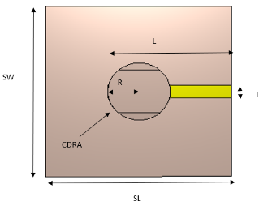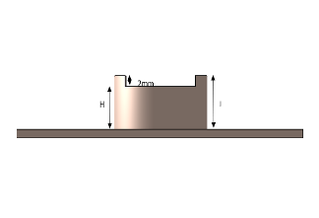

(b)

(a)

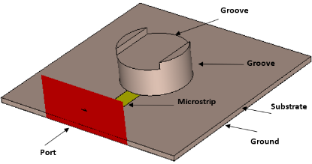

(c)

Figure 1 illustrates the geometry of the proposed CDRA sensor, featuring (a) a top view, (b) a side view, and (c) a perspective view.

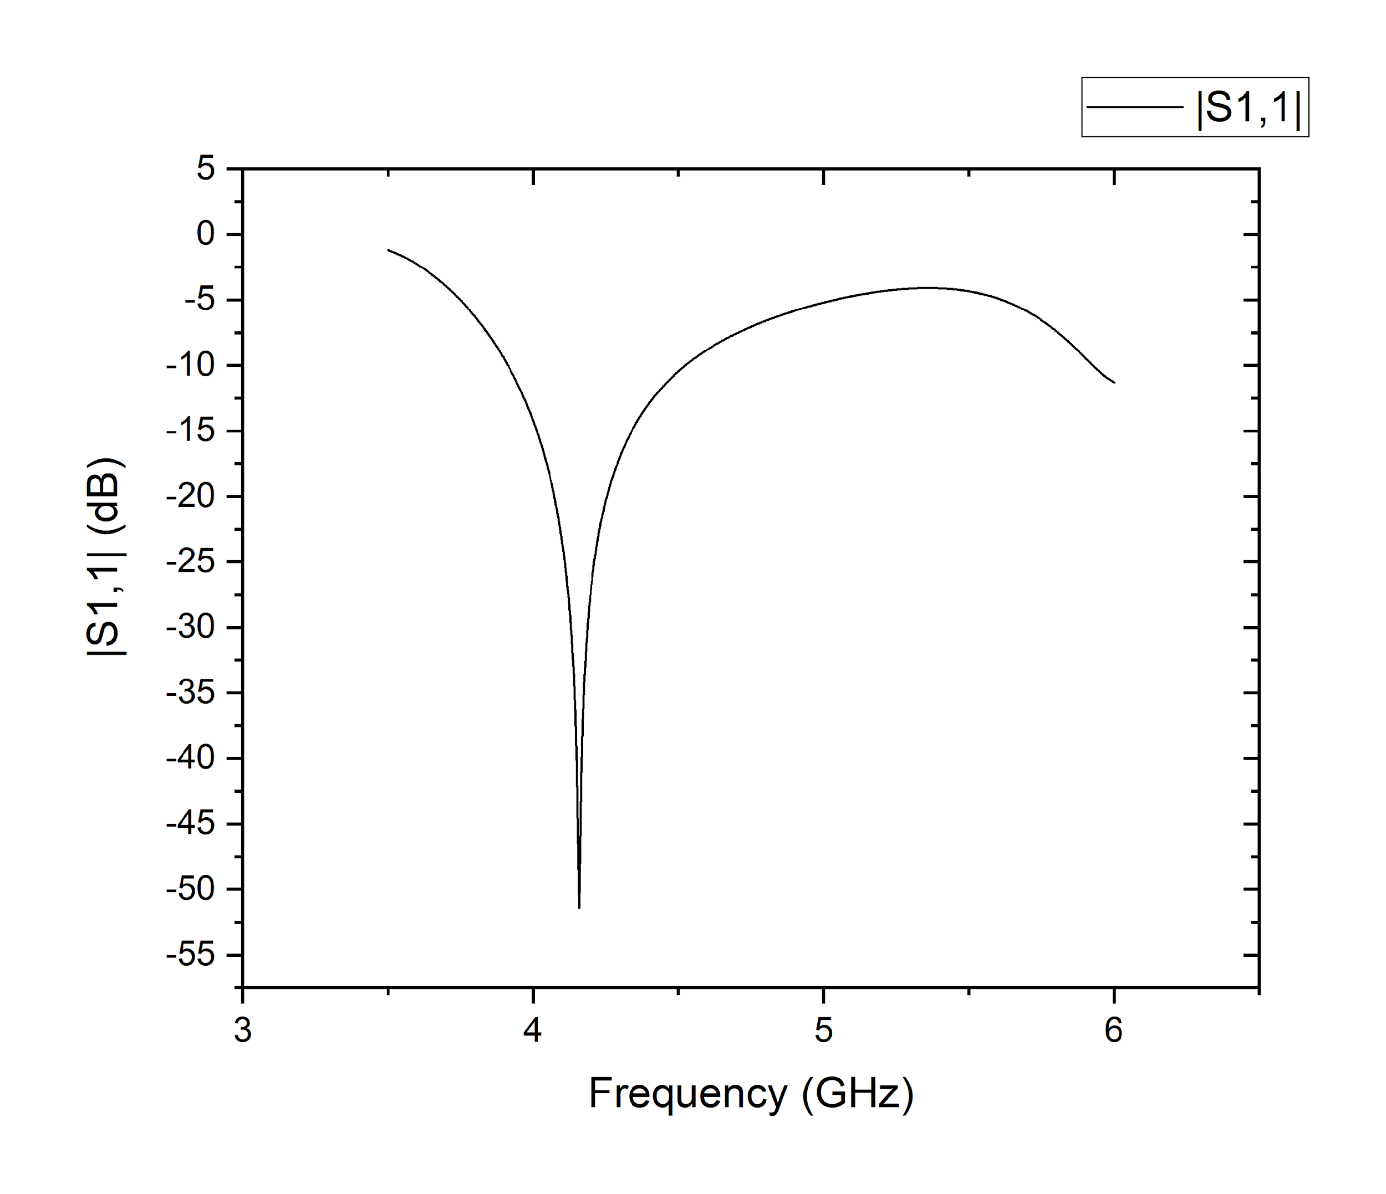

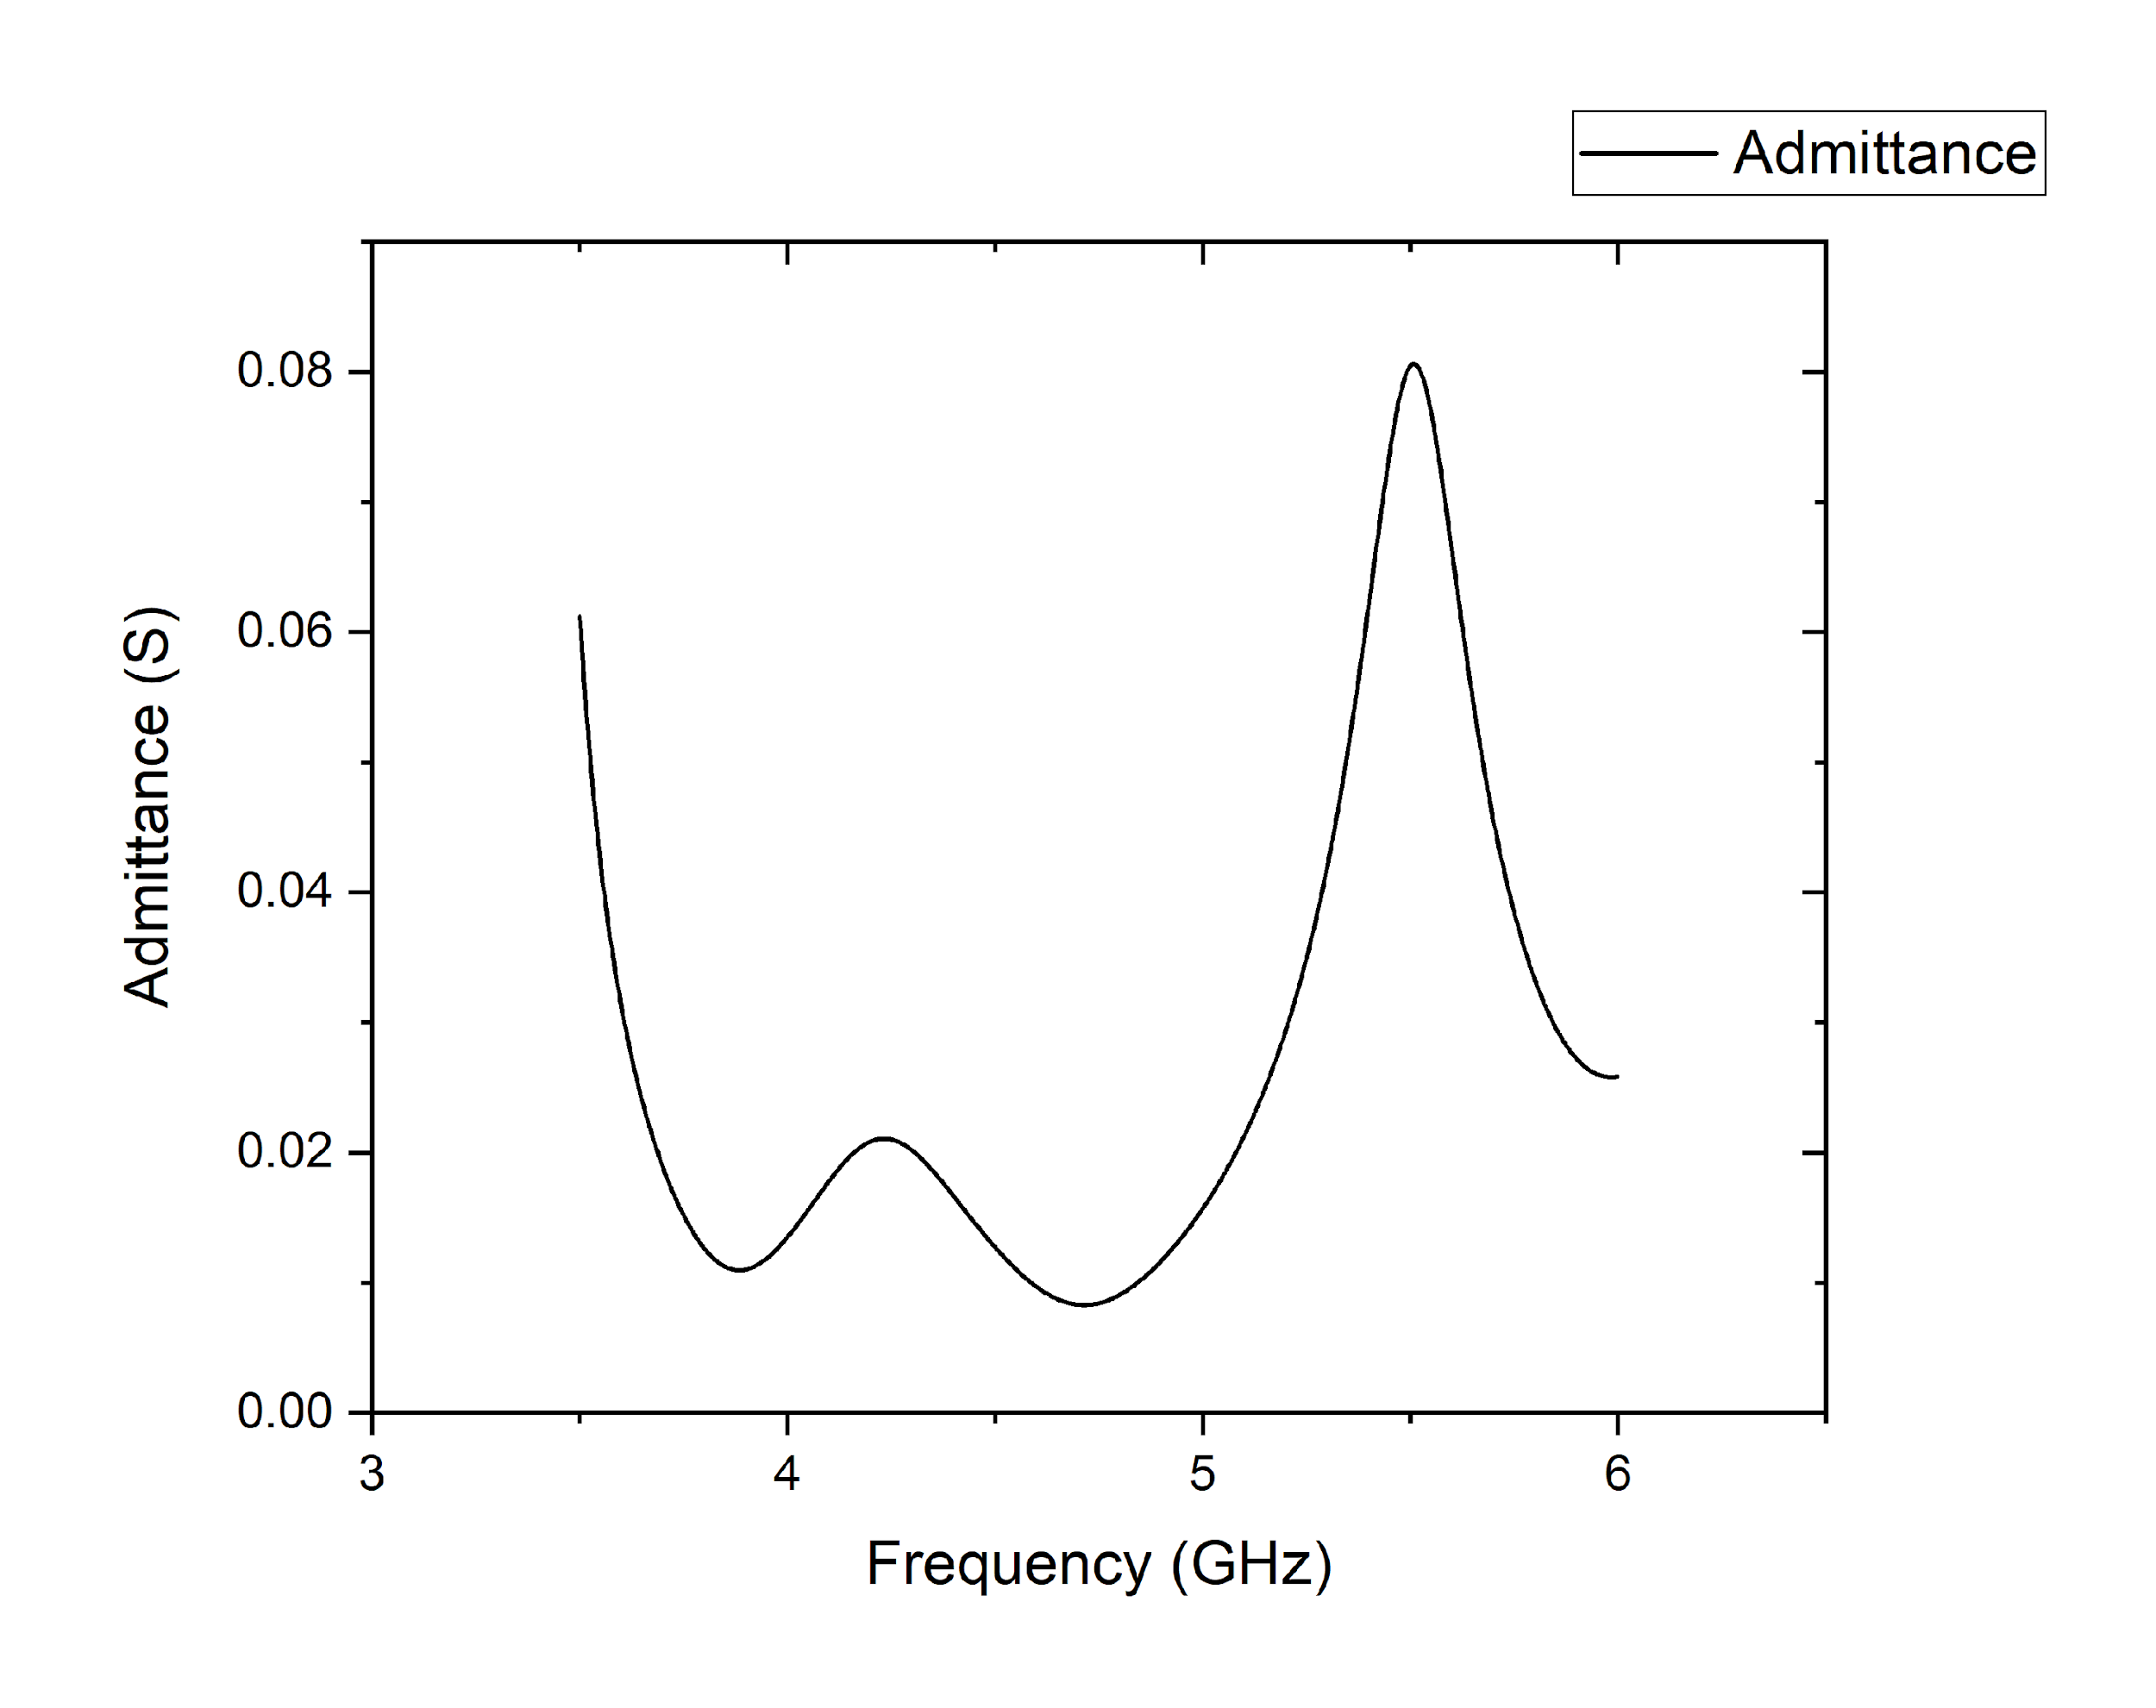(a)

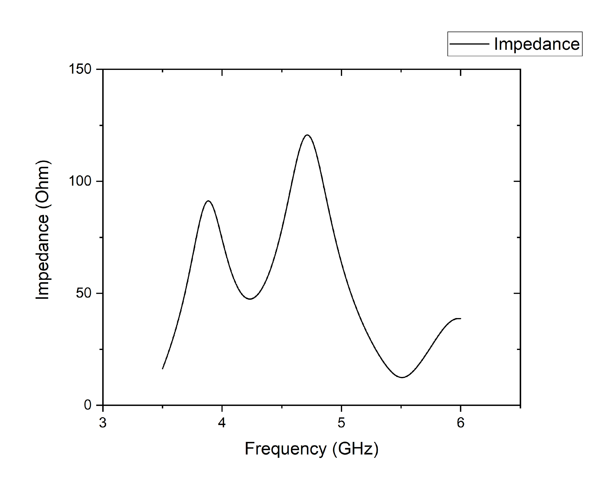(b)

(c)

Figure 2 showcases the outcomes of the suggested CDRA sensor, including (a) the reflectance plot, (b) the admittance plot, and (c) the impedance plot.

**III. ELECTROMAGNETIC MODELING OF HUMAN THUMB**

This portion delves into the topic of EM modeling of the human thumb in depth. Human tissues, unlike homogeneous dielectric materials, are made up of many layers of a complex inhomogeneous combination of bio-organic components with varying electromagnetic characteristics. In computational bio-electronics research, voxel based EM models of human tissues are commonly used. The primary concept of non-invasive glucose sensing, on the other hand, is aimed at detecting even the slightest variations in the permittivity of human blood caused by changes in concentration of glucose. It means that the blood's permittivity is a function of its glucose content. This is the most important factor to include in any electromagnetic simulation of blood glucose sensing.

While a voxel based technique may provide great 3D geometric representations of the human thumb, it is impossible to account for the complicated permittivity of blood and glucose content in a voxel model.

The Cole-Cole model is widely used to simulate human tissues electromagnetically as a function of the frequency.

The dielectric permittivity (ε) of blood, which varies with frequency, may be described by the following equation, where the angular frequency and 𝜎i represent conductivity, according to the Cole-Cole model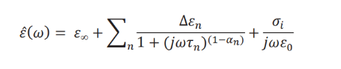.

The blood was classified as a single pole (n=1) "Cole-Cole material" and the corresponding values of the dispersion magnitude (Δεn), relaxation time constant (τn), dispersion-broadening parameter (αn = 0.1), and high-frequency permittivity (ε∞) were entered into CST Microwave Studio. To measure the dependence of blood permittivity on glucose concentration, this was done over a range of glucose concentrations starting at 16,000 mg/dL.

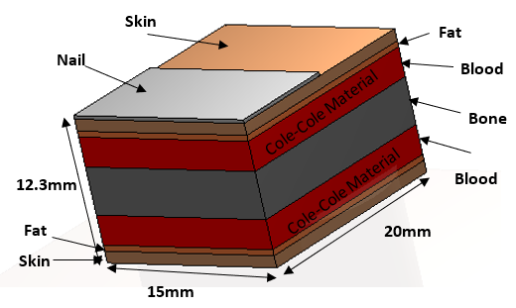

Fig. 3 illustrates the construction of a 3D layer-based simplified human thumb electromagnetic (EM) model in CST Microwave Studio

In figure 3 the blood is designated as Cole-Cole material. Blood layers in the EM model have sizes that are roughly appropriate for an adult. In Fig 3, only the fingertip of the thumb is modeled to concentrate on the significant variables, such as blood permittivity and glucose dependency. The dimensions of the thumb tissue model are 15 mm x 20 mm x 12.3 mm. Since the blood's permittivity in non-invasive glucose sensing depends on the frequency and glucose concentration, only the blood layers are simulated as Cole-Cole

material.

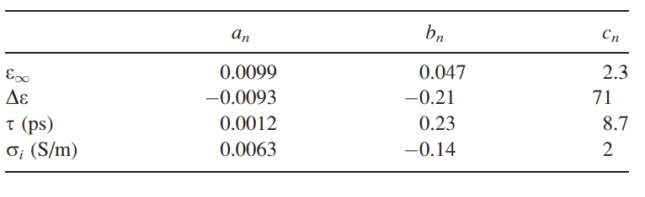

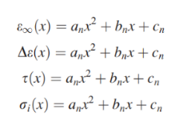

x is Glucose Concentration in g/dl

**IV. RESULTS AND DISCUSSION**

***A. Glucose Detection***

The suggested CDRA sensor has a resonance frequency of 4.155 GHz, as indicated in the second section. Any variation in the antenna's input impedance is expected to produce a shift in resonance since the antenna's reflection coefficient (|S11|) is reliant on its input impedance (Zin). The reflection coefficient (|S11|) and input impedance (Zin) are mathematically related, as shown in the following equation, where Z0 is the characteristic impedance, which is typically 50 ohms for the majority of microwave components and devices.

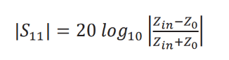

The i/p impedance of the proposed CDRA changes

when thumb is applied to it, as shown in Figure 3, which causes the resonance frequency to shift from 4.155 GHz to 4.7825 GHz. The thumb model used in this scenario has a glucose concentration of 0 mg/dL, as demonstrated in the reflection coefficient plots of Figure 4. The thumb is placed on an area with significant electric fields in both cut planes, according to the field distributions. While electric fields are parallel along the cut plane parallel to the thumb's placement, they are perpendicular to the cut plane normal to the thumb's location.

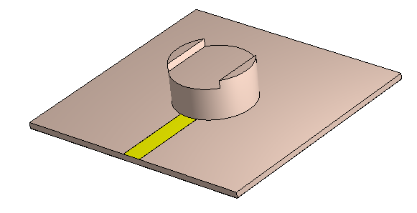

(a)

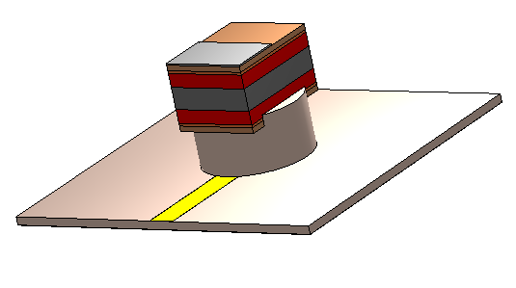

(b)

Figure 4 illustrates the proposed CDRA sensor both without and with the thumb.

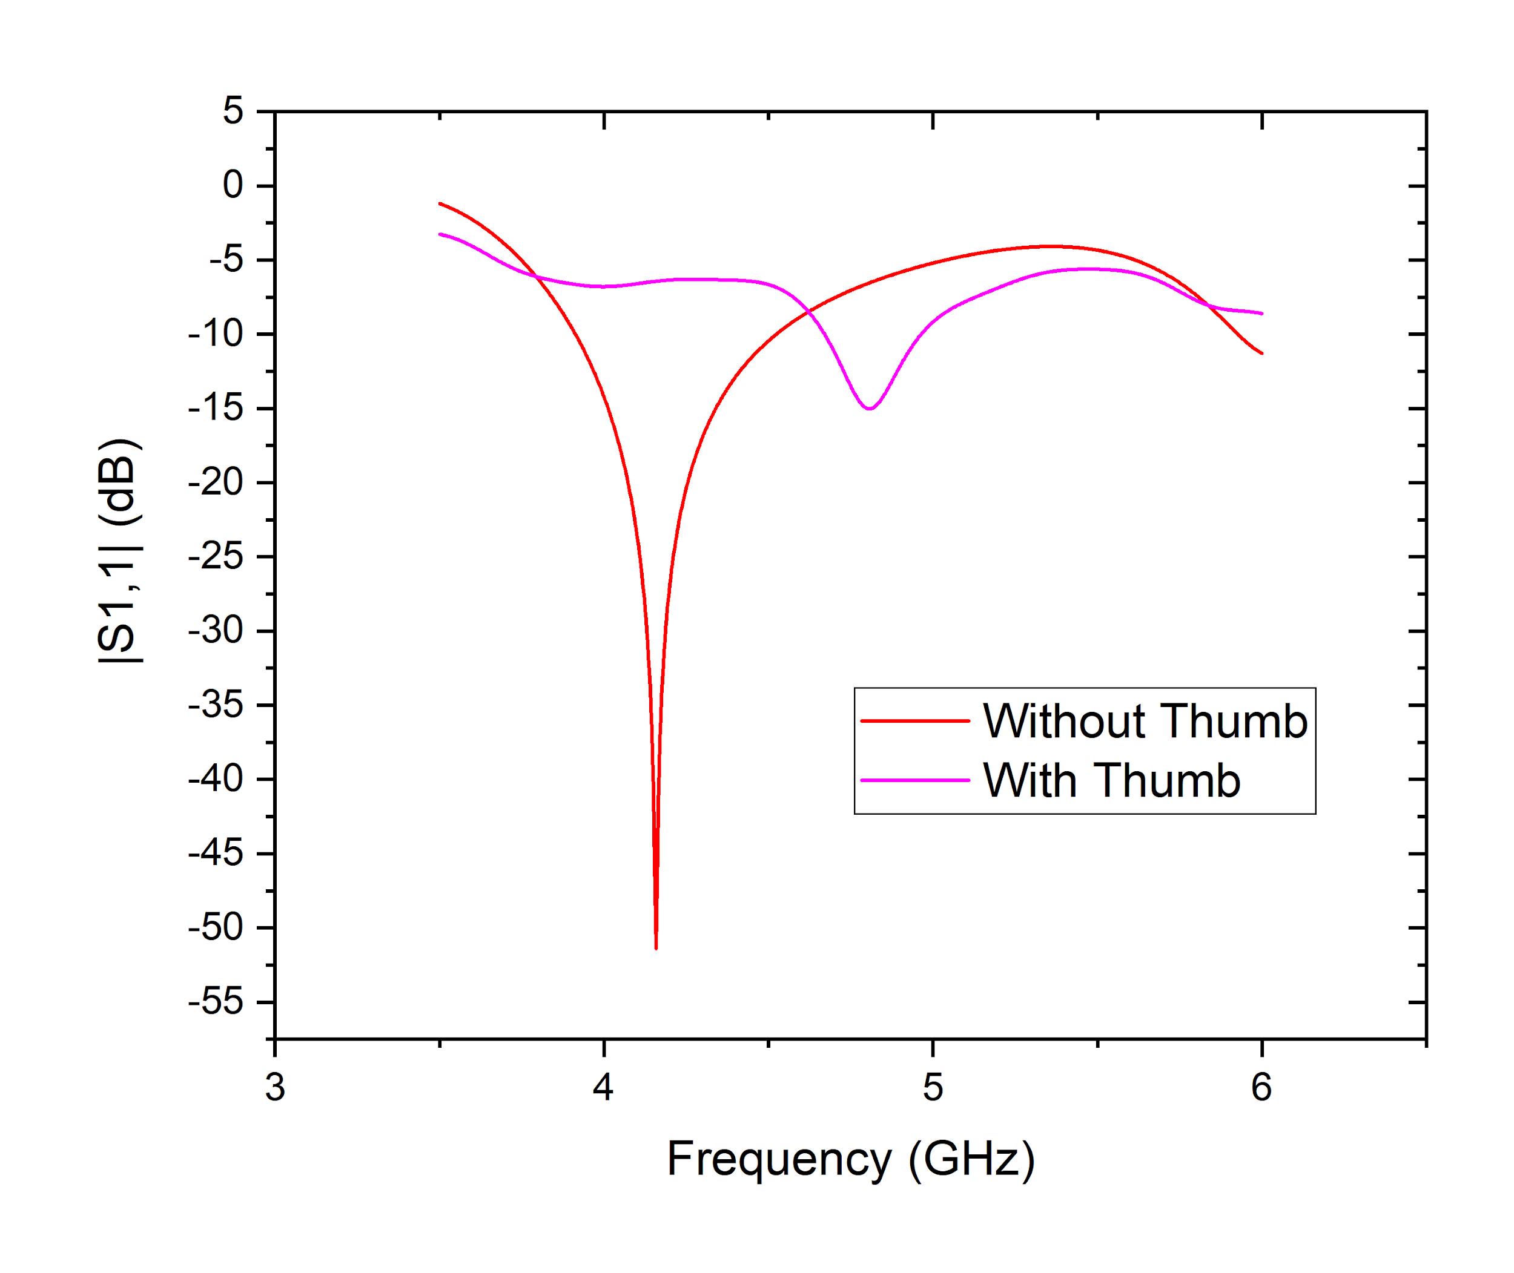

The suggested CDRA sensor's reflection coefficient is shown in Figure 5 both without and with the EM thumb model.

A cylindrical dielectric resonator antenna without the thumb model is shown in Figure 4(a), while an antenna with the thumb model is shown in Figure 4(b). Additionally, Figure 5 compares the cylindrical dielectric resonator antenna's reflection coefficient with and without the human thumb model. The resonant frequency shifts to 4.7825 GHz (with the Thumb model) from 4.155 GHz (without it).

Many simulations are then run with the thumb's blood glucose levels varied from 0 mg/dl - 16,000 mg/dl.

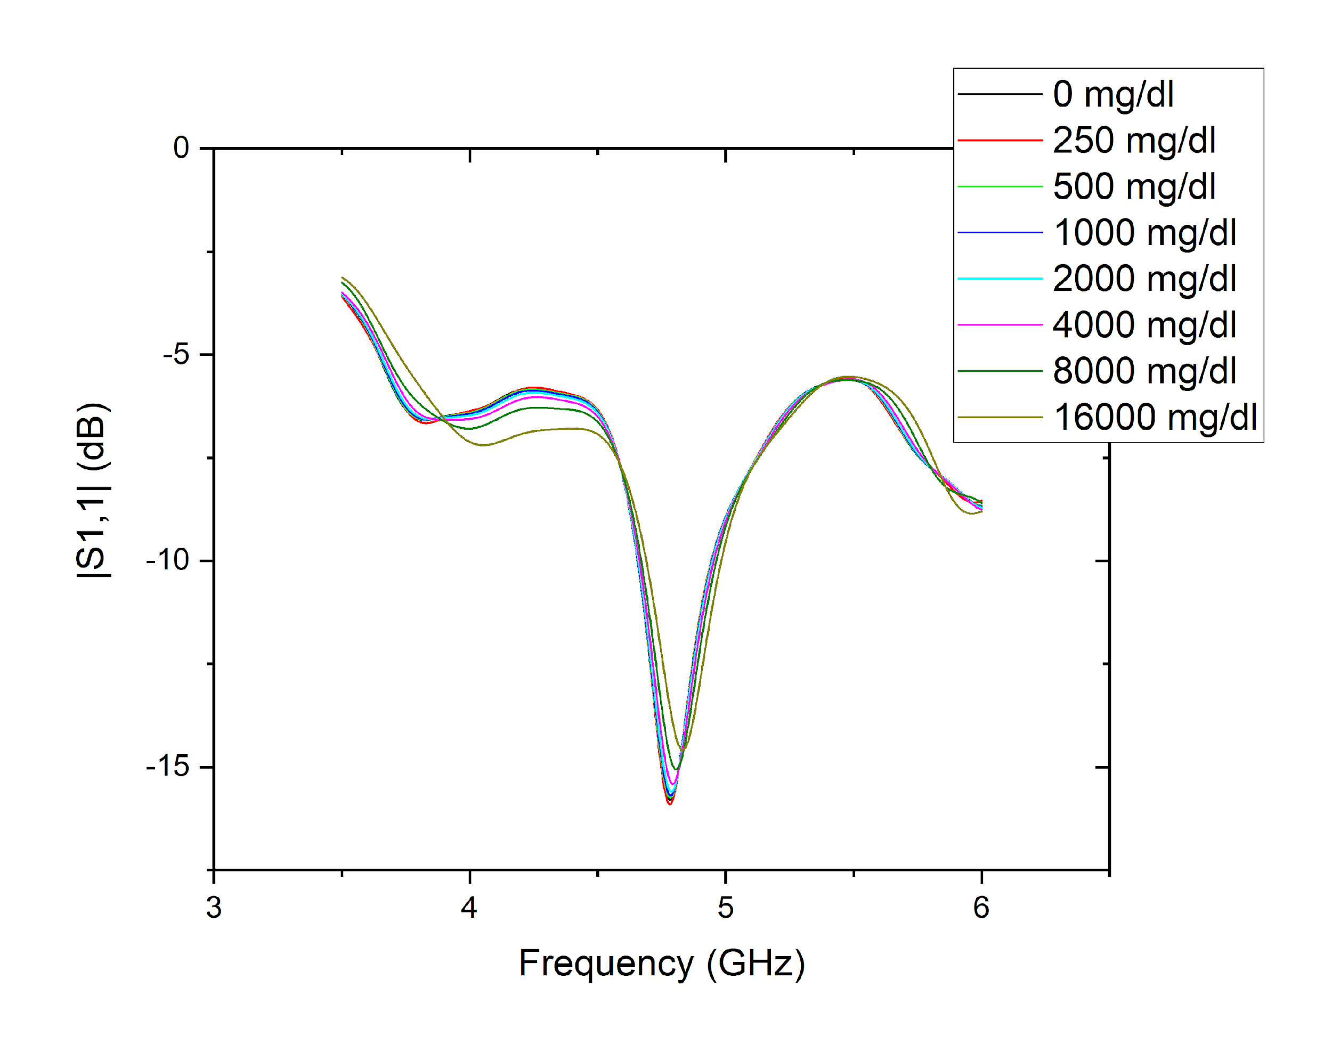

Figure 6 illustrates the suggested CDRA sensor's reflection coefficient plot for different glucose concentrations.

Table II: PROPOSED CDRA SENSOR'S RESONANCE FREQUENCY FOR DIFFERENT GLUCOSE CONCENTRATIONS

|  |  |  |  |  |
| --- | --- | --- | --- | --- |
| Glucose concentration  (mg/dL) | 0 | 250 | 500 | 1000 |
| Resonance frequency  (GHz) | 4.7825 | 4.7825 | 4.7825 | 4.785 |
| Glucose concentration  (mg/dL) | 2000 | 4000 | 8000 | 1600 |
| Resonance frequency (GHz) | 4.7875 | 4.7925 | 4.805 | 4.8325 |

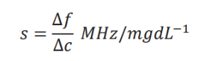As expected, the resonant frequencies of the suggested CDRA sensor show approximately linear fluctuation with increasing variations in blood glucose level, as shown in Table II. Furthermore, Table II makes it clear that the suggested CDRA sensor's resonant frequencies for 0, 250, 500, and 1000 mg/dL don't vary. Conversely, the corresponding values of the reflection coefficient are -15.79 dB, -15.90 dB, -15.73 dB, and -15.68 dB. The frequency changes seen at different concentrations of glucose allow us to compute the suggested sensor's sensitivity (s).

where ff represents the shift in net frequency (MHz) and cc denotes the net glucose concentration changes (mg/dL). The sensitivity can be determined from Table II as follows:

s = 3.12 *kHz/mgdL-1*

**V. CONCLUSION**

By positioning the thumb on the sensor platform, one can use the CDRA based glucose sensor presented in this research to monitor blood glucose concentration. The suggested sensor's working frequency is 4.155 GHz. The suggested sensor works well in a simulated model, transforming it into a good contender for an inexpensive continuous glucose sensing for diabetic patients.

**REFERENCES**

[1] U. Illahi et al., "Design of New Circularly Polarized Wearable Dielectric Resonator Antenna for Off-Body Communication in WBAN Applications," in IEEE Access, vol. 7, pp. 150573-150582, 2019, doi: 10.1109/ACCESS.2019.2947772.

[2] J. Lai et al., "Design of a Dual-Polarized Omnidirectional Dielectric Resonator Antenna for Capsule Endoscopy System," in IEEE Access, vol. 9, pp. 14779-14786, 2021, doi: 10.1109/ACCESS.2021.3052601.

[3] Ryu, Kenny & Kishk, Ahmed. (2011). Evaluation of Dielectric Resonator Sensor for Near-Field Breast Tumor Detection. Antennas and Propagation, IEEE Transactions on. 59. 3738 - 3745. 10.1109/TAP.2011.2163790.

[4] Schmidt, Rita and Andrew G. Webb. “Characterization of an HEM-Mode Dielectric Resonator for 7-T Human Phosphorous Magnetic Resonance Imaging.” *IEEE Transactions on Biomedical Engineering* 63 (2016): 2390-2395.

[5] S. A. A. Shah and H. Yoo, "Scalp-Implantable Antenna Systems for Intracranial Pressure Monitoring," in IEEE Transactions on Antennas and Propagation, vol. 66, no. 4, pp. 2170-2173, April 2018, doi: 10.1109/TAP.2018.2801346.

[6] Yaduvanshi, R. S., Yadav, R. K., Katiyar, S., Kumar, S., and Parthasarathy, H., “Optical spherical dielectric resonator antenna for sensing and wireless communication”, <i>Frequenz</i>, vol. 75, no. 1–2, pp. 49–59, 2021. doi:10.1515/freq-2020-0086

[7] A. Iqbal, A. J. Alazemi and N. Khaddaj Mallat, "Slot-DRA-Based Independent Dual-Band Hybrid Antenna for Wearable Biomedical Devices," in IEEE Access, vol. 7, pp. 184029-184037, 2019, doi: 10.1109/ACCESS.2019.2960443.

[8] Altaf, Amir, and Munkyo Seo. 2020. "Dual-Band Circularly Polarized Dielectric Resonator Antenna for WLAN and WiMAX Applications" *Sensors* 20, no. 4: 1137. https://doi.org/10.3390/s20041137

[9] M. S. Iqbal and K. P. Esselle, "A compact wideband dielectric resonator antenna for on-body applications," 2014 IEEE MTT-S International Microwave Workshop Series on RF and Wireless Technologies for Biomedical and Healthcare Applications (IMWS-Bio2014), 2014, pp. 1-3, doi: 10.1109/IMWS-BIO.2014.7032383.

[10] Gwladys Laure, Makiela Fokoa & Uyguroglu, Rasime. (2019). Conical, Stair-Shapedand Cylindrical Dielectric Resonator Antenna for Early Breast Cancer Detection Application. 1-4. 10.1109/SIU.2019.8806528.

[11] Ali, & Jamaluddin, & Gaya, Abinash & Rahim,. (2020). A Dielectric Resonator Antenna with Enhanced Gain and Bandwidth for 5G Applications. Sensors. 20. 675. 10.3390/s20030675.

[12] Beibei Xing, Yueyuan Zhang, Hui Zou, and Zhiwei Liu, "A Conformal Quasi-Isotropic Dielectric Resonator Antenna for Wireless Capsule Endoscope Application," Progress In Electromagnetics Research M, Vol. 99, 211-221, 2021.  
doi:[10.2528/PIERM20091901](http://dx.doi.org/10.2528/PIERM20091901)

[13] Sarah Majid Obaid, Taha Ahmed Elwi, and Muhammad Ilyas, "Fractal Minkowski-Shaped Resonator for Noninvasive Biomedical Measurements: Blood Glucose Test," Progress In Electromagnetics Research C, Vol. 107, 143-156, 2021.  
doi:[10.2528/PIERC20072603](http://dx.doi.org/10.2528/PIERC20072603)

[14] Munteanu, Irina and Ilari Hanninen. “Recent advances in CST STUDIO SUITE for antenna simulation.” *2012 6th European Conference on Antennas and Propagation (EUCAP)* (2012): 1301-1305.

[15] Suwanta, P. & Krachodnok, P. & Wongson, R.. (2017). Wideband inverted L-shaped dielectric resonator antenna for medical applications. 188-189. 10.1109/COMPEM.2017.7912828.

[16] Mukherjee, Biswajeet & Patel, Pragati & Mukherjee, Jayanta. (2020). A review of the recent advances in dielectric resonator antennas. Journal of Electromagnetic Waves and Applications. 34. 1-64. 10.1080/09205071.2020.1744484.

[17] Zhijie, Yang & Xiao, Shao-Qiu & Zhu, Lei & Wang, Bing-Zhong & Tu, Hui-Lin. (2017). A Circularly Polarized Implantable Antenna for 2.4 GHz ISM Band Biomedical Applications. IEEE Antennas and Wireless Propagation Letters. PP. 1-1. 10.1109/LAWP.2017.2732460.

[18] Iqbal, Amjad, Amor Smida, Omar A. Saraereh, Qais H. Alsafasfeh, Nazih K. Mallat, and Byung M. Lee 2019. "Cylindrical Dielectric Resonator Antenna-Based Sensors for Liquid Chemical Detection" *Sensors* 19, no. 5: 1200. https://doi.org/10.3390/s19051200

[19] Li, Rongqiang, Yong-xin Guo and Guo-hong Du. “A Conformal Circularly Polarized Antenna for Wireless Capsule Endoscope Systems.” *IEEE Transactions on Antennas and Propagation* 66 (2018): 2119-2124.

[20] Selvaraju, Raghuraman & Kamarudin, M.R. & Khalily, Mohsen & Nasir, Jamal & Jamaluddin, Mohd haizal. (2016). Dual band rectangular dielectric resonator

antenna for WLAN application. Jurnal Teknologi